Testcase 1:GCP deployments in multiple environments and Projects using Terraform workspaces

* Created Terraform workspaces

1. dev
2. test

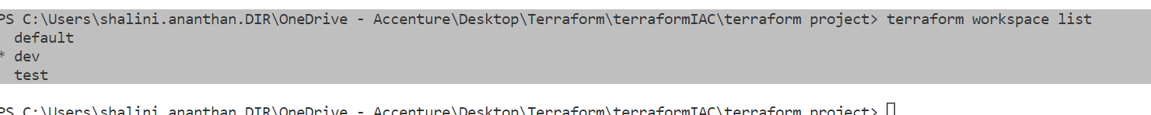

* Terraform projects in gcp console for each workspaces .

1. gcp-terraform-dev-348811
2. gcp-terraform-test-348811
3. gcp-terraform-348507(default)

* Recourses for each project and stored the values in variables using functions(lookup)

1. google_compute_instance
2. google_storage_bucket
3. google_compute_network
4. google_compute_subnetwork
5. google_compute_firewall

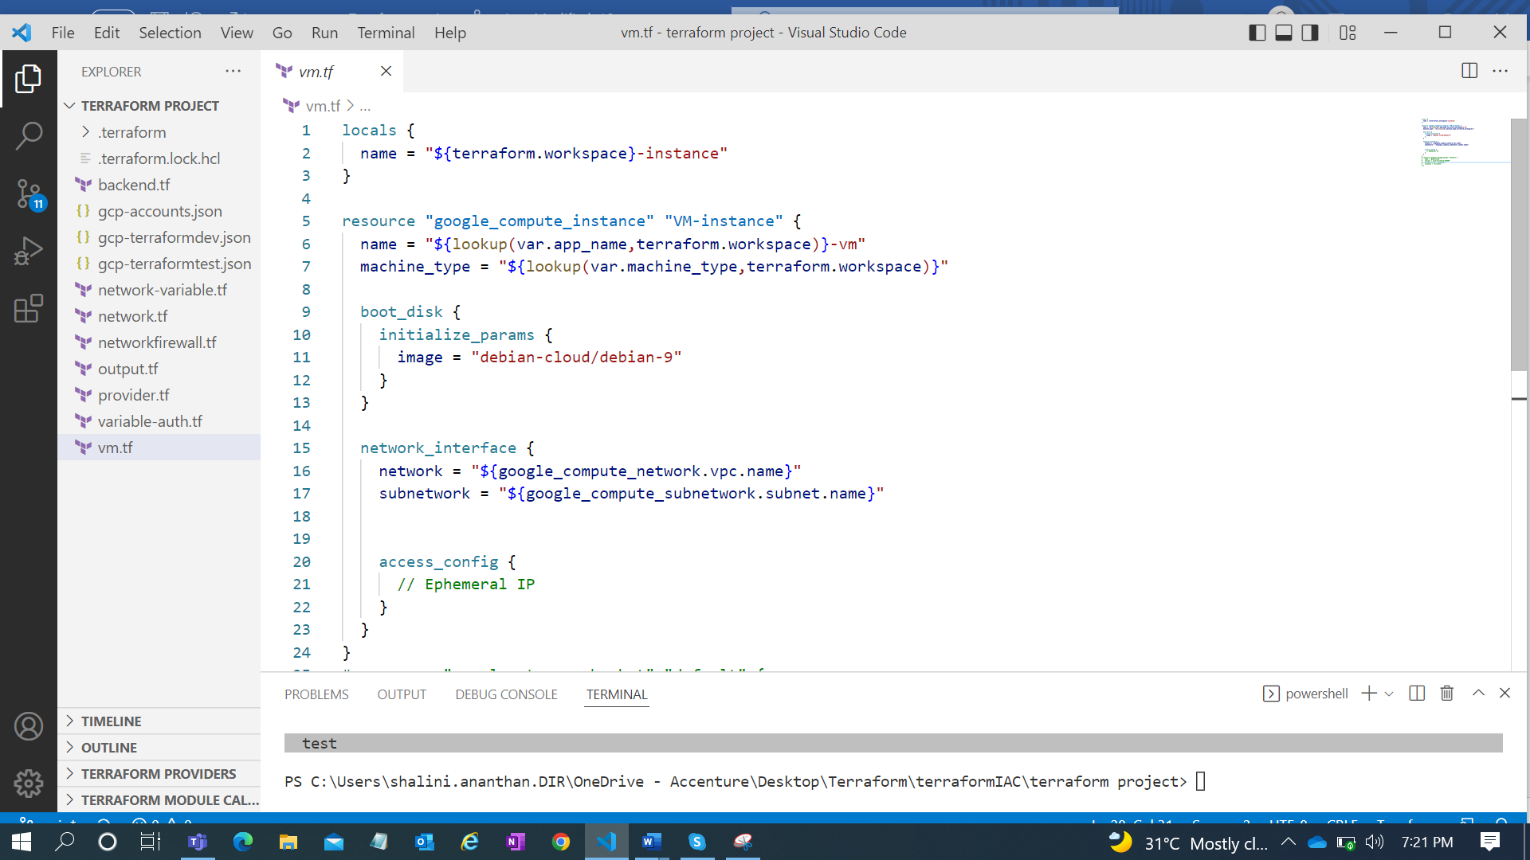

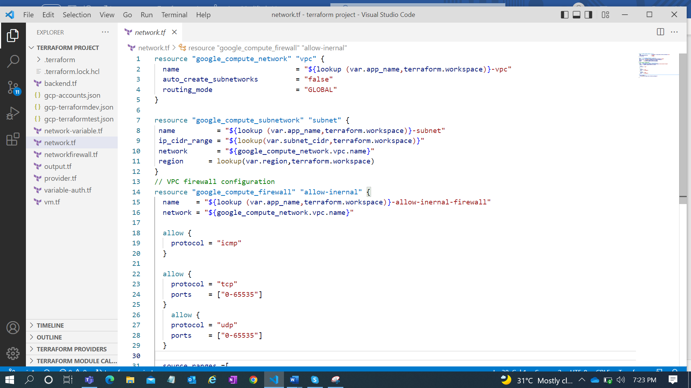

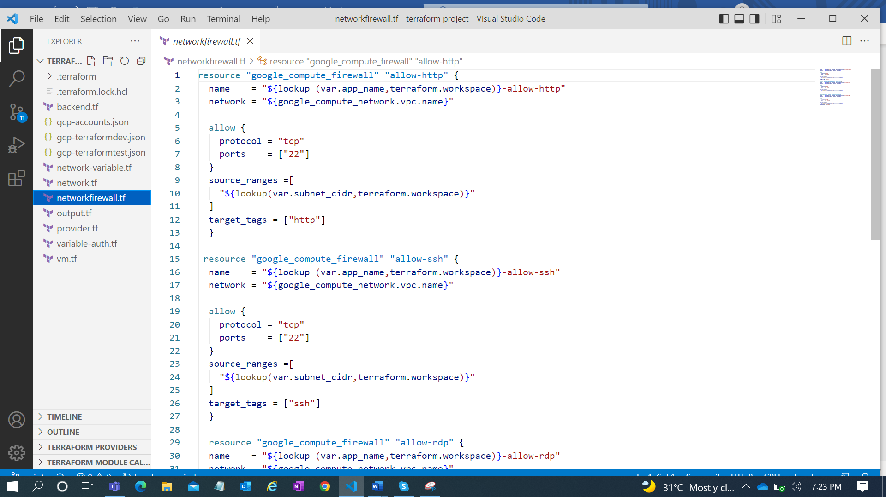

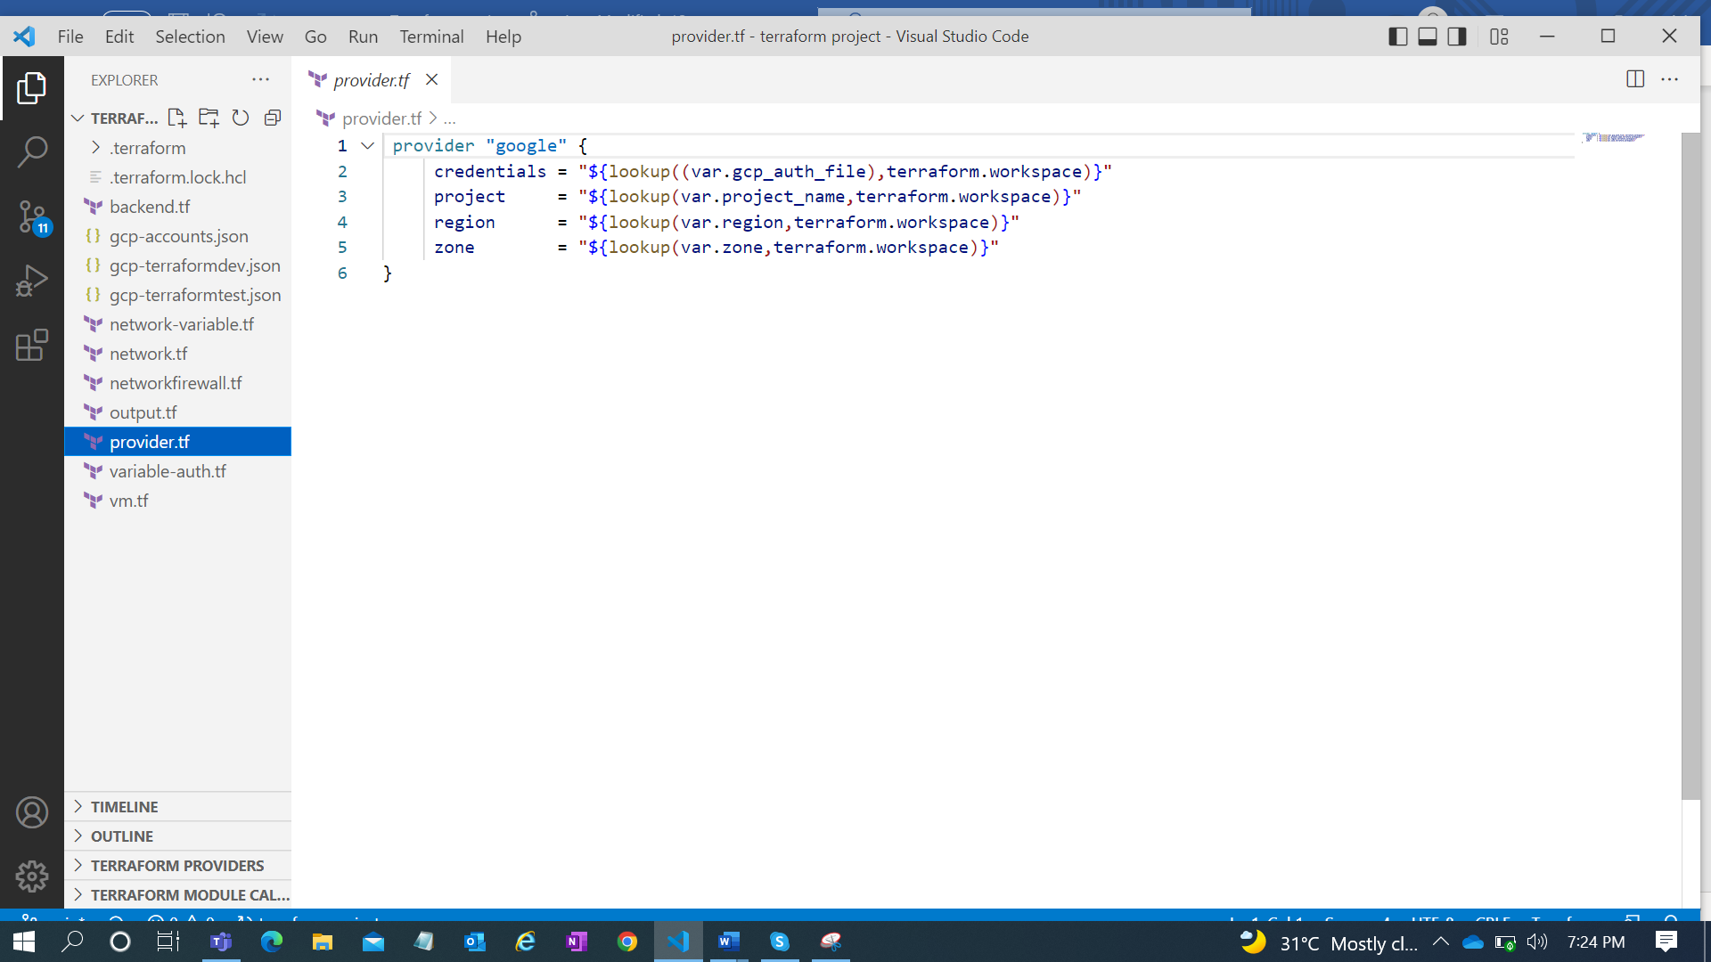

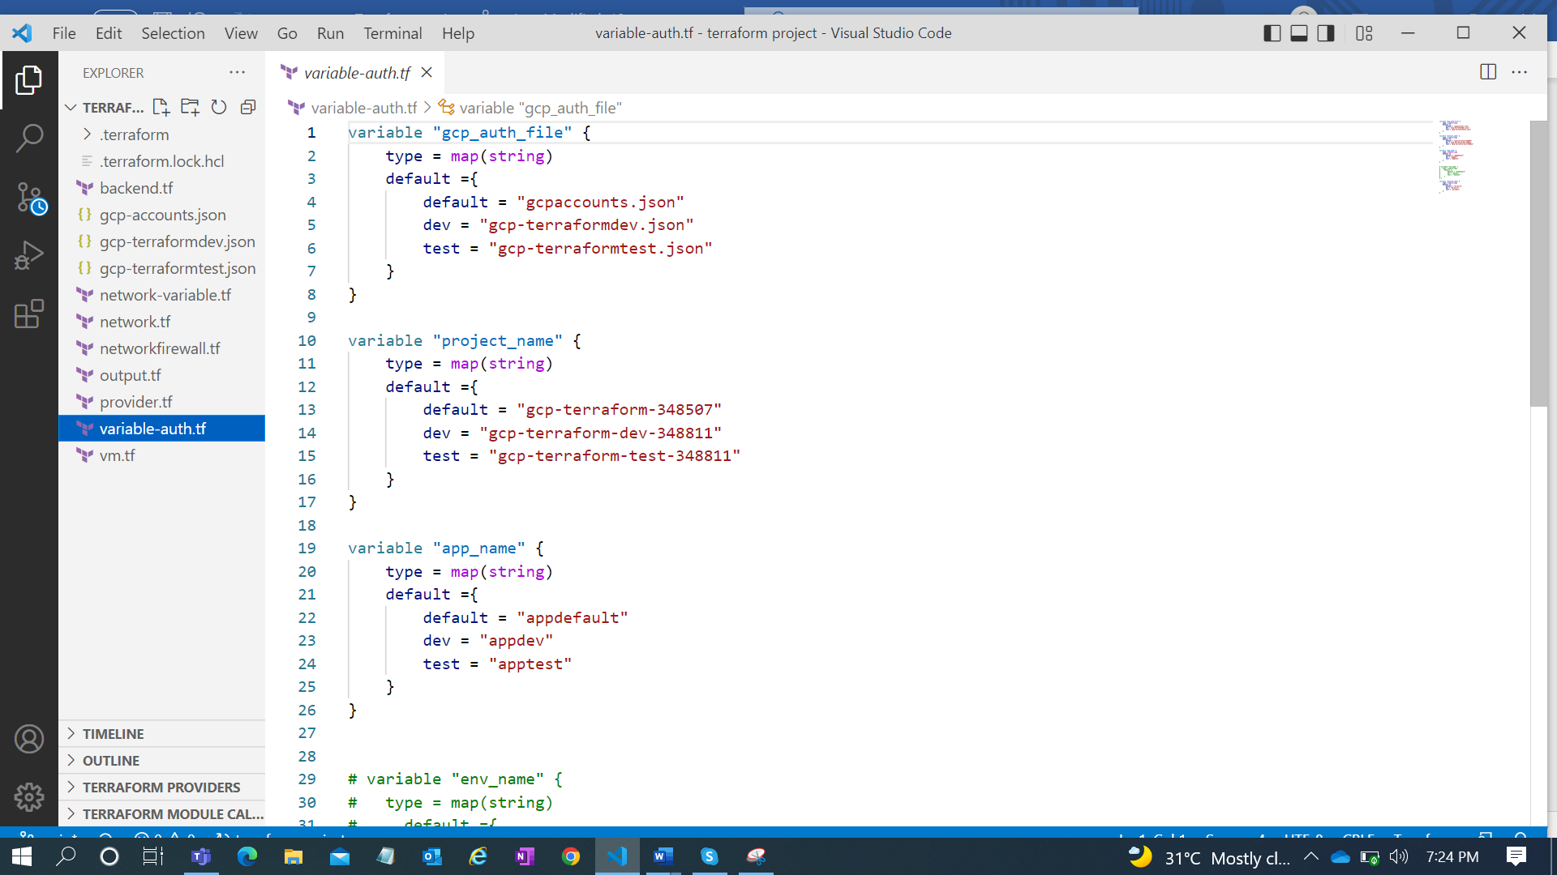

* Backend.tf is created and stored the files remotely in gcs bucket.

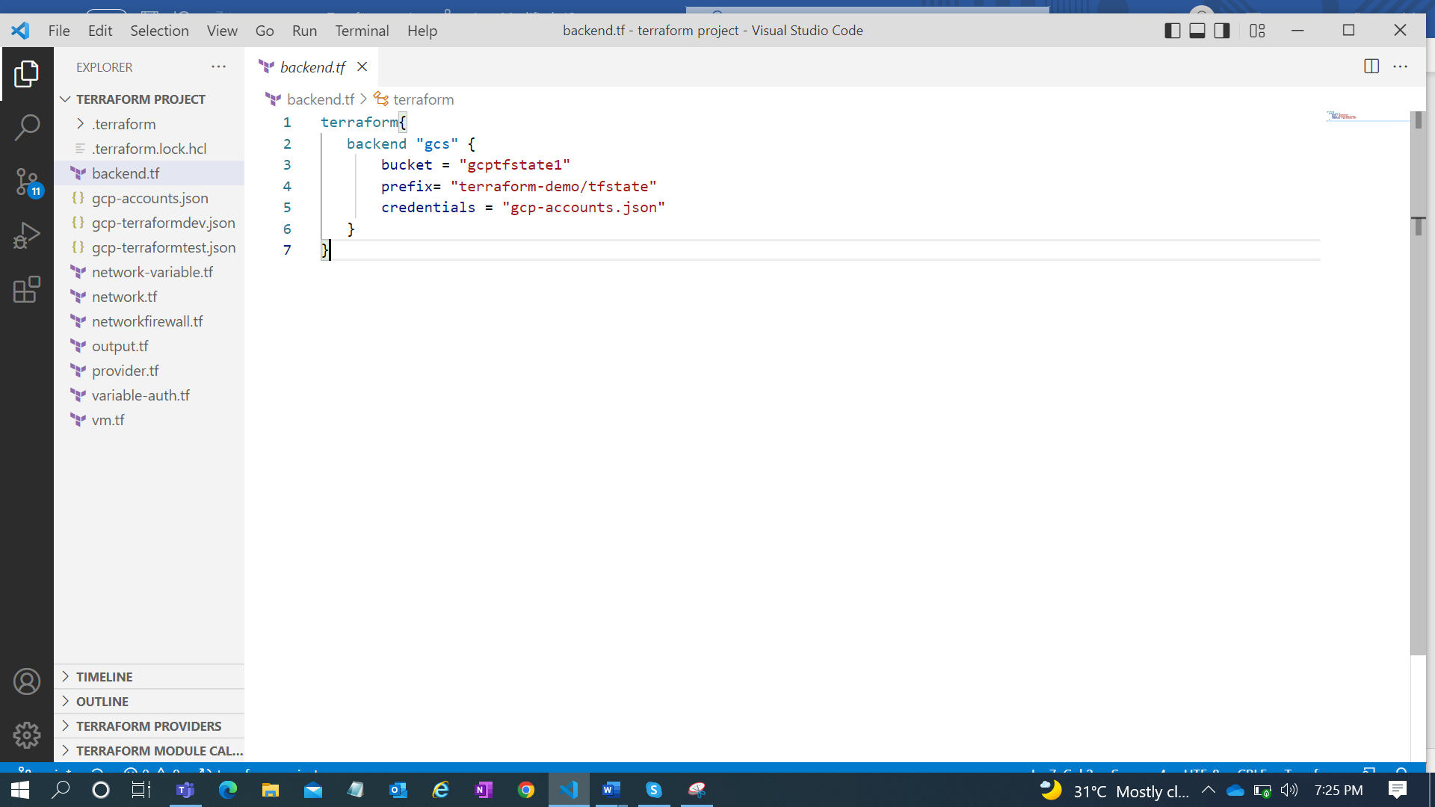

* Moved to another location and tested using terraform validate command
* Code has been added to git hub and tested in migrate state .

Result:

Terraform scripts can able to deploy the resources in different env as expected .

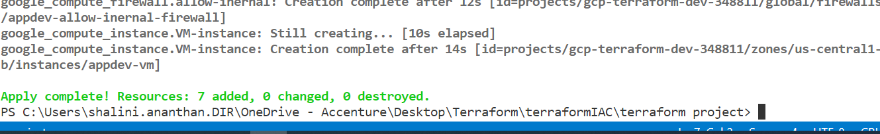

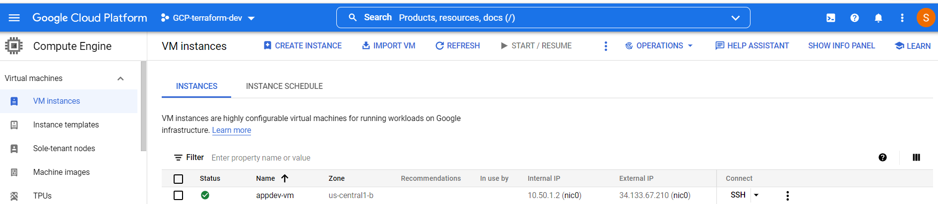

Testcase 2 :Creating multiple VM’S Using Count and For each functions

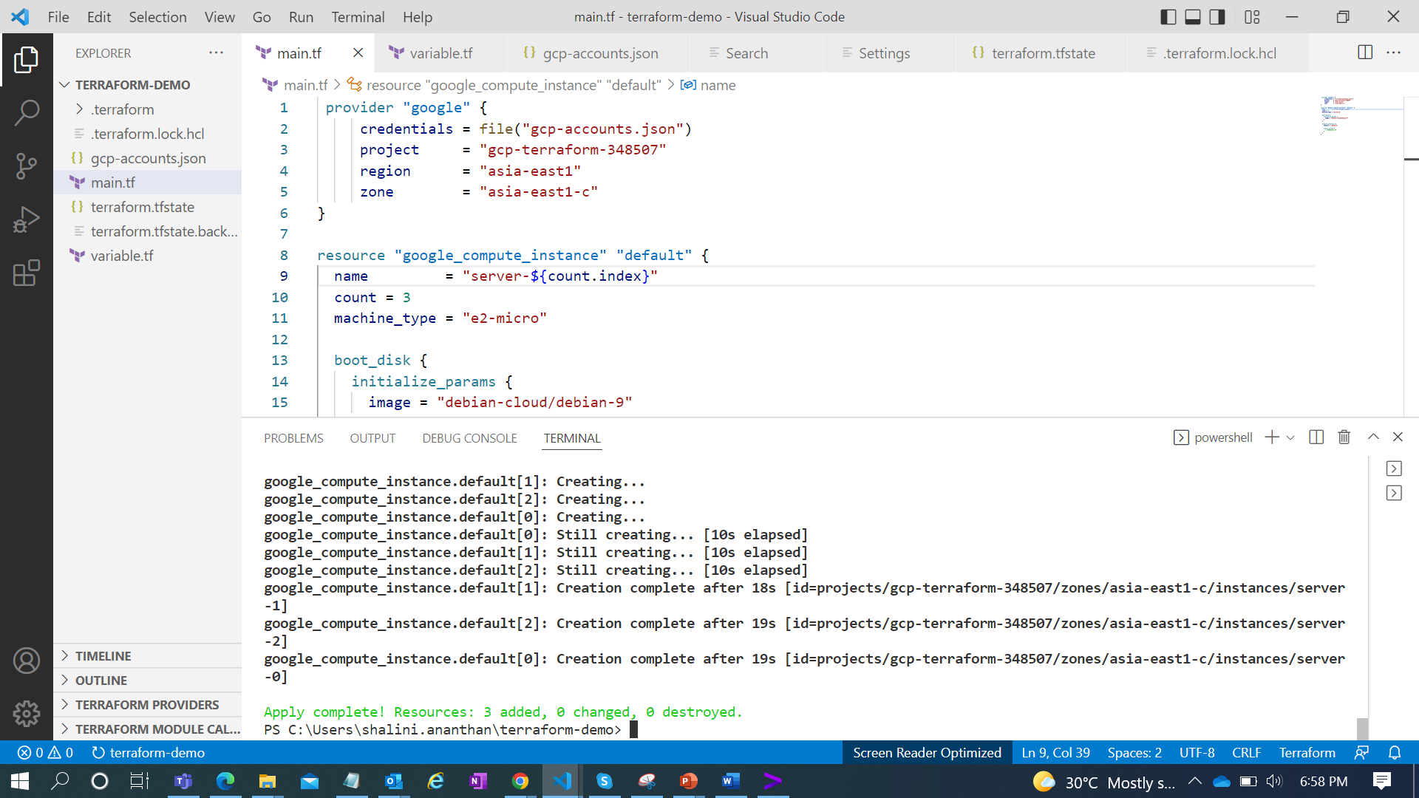

For Each :



Testcase 3: To run specific resources using Terraform Apply command

Command:

Terraform apply -target =resourcename.name

